University of Ghana Smart Campus Service Operations Optimizer
Sorting Module Deliverable
DCIT 204 – Data Structures and Algorithms I

1. Module Overview
As part of Group B (Level 200), this deliverable implements the Sorting Module for the Smart Campus Service Operations Optimizer. The module provides three custom-built sorting algorithms — Insertion Sort, Merge Sort, and Quick Sort — that operate on ServiceRequest records and can sort by any of the three keys the project requires: urgency, submission time, and deadline.
Per the project's assignment constraints, no built-in Java data structures (HashMap, TreeMap, PriorityQueue, Stack, ArrayDeque) or built-in sort utilities were used for the core sorting logic. Arrays.sort() is used in exactly one place — as a correctness oracle during testing only — and never inside the sorting algorithms themselves.
Deliverables covered in this document:
- Sorting package — InsertionSort.java, MergeSort.java, QuickSort.java, RequestComparators.java
- Algorithm comparison — theoretical time/space complexity and stability
- Execution time measurements — real, measured runtimes across growing dataset sizes

2. Design Approach
Rather than writing three separate copies of each algorithm (one per sort key), each sorting class exposes a single sort(ServiceRequest[], Comparator<ServiceRequest>) method. A small RequestComparators helper class defines the three comparison rules once. This keeps the sorting logic reusable and matches how the Search and Graph modules (Groups A and D) will consume the same ServiceRequest objects.
import java.util.Comparator;

/**
* Central place for the three comparison rules Group B needs to support:
* 1. By urgency (High -> Medium -> Low)
* 2. By submission time (earliest first)
* 3. By deadline (soonest first)
*
* These are plain Comparator objects (not a banned built-in data structure),
* and are passed into our own InsertionSort / MergeSort / QuickSort classes
* so the same three sorting algorithms can sort by any of the three keys.
*/
public class RequestComparators {

public static final Comparator<ServiceRequest> BY_URGENCY =
(a, b) -> b.getUrgency().getWeight() - a.getUrgency().getWeight();

public static final Comparator<ServiceRequest> BY_SUBMISSION_TIME =
(a, b) -> a.getSubmissionTime().compareTo(b.getSubmissionTime());

public static final Comparator<ServiceRequest> BY_DEADLINE =
(a, b) -> a.getDeadline().compareTo(b.getDeadline());
}

3. Implementation

3.1 Insertion Sort
Insertion Sort builds the sorted array one element at a time by shifting larger elements to the right. It is simple, stable, and in-place, and performs very well when a batch of requests is already nearly sorted — e.g. re-sorting a queue after only one or two new requests arrive.
import java.util.Comparator;

/**
* Custom Insertion Sort.
*
* Time complexity : Best O(n) | Average O(n^2) | Worst O(n^2)
* Space complexity: O(1) (in-place)
* Stable : Yes
*
* Good for small or nearly-sorted request batches (e.g. a short queue of
* newly arrived requests that only needs light re-ordering).
*/
public class InsertionSort {

public static void sort(ServiceRequest[] requests, Comparator<ServiceRequest> comparator) {
int n = requests.length;
for (int i = 1; i < n; i++) {
ServiceRequest key = requests[i];
int j = i - 1;
while (j >= 0 && comparator.compare(requests[j], key) > 0) {
requests[j + 1] = requests[j];
j--;
}
requests[j + 1] = key;
}
}
}

Figure 2. InsertionSort.java

3.2 Merge Sort
Merge Sort recursively splits the array in half, sorts each half, and merges the results. It guarantees O(n log n) performance regardless of the input's initial order, making it the safest default for sorting the full request dataset.
import java.util.Comparator;

/**
* Custom Merge Sort (top-down, recursive, divide and conquer).
*
* Time complexity : Best O(n log n) | Average O(n log n) | Worst O(n log n)
* Space complexity: O(n) (needs an auxiliary array for merging)
* Stable : Yes
*
* Good choice when we need predictable, guaranteed O(n log n) performance
* regardless of how the incoming request batch is ordered, e.g. nightly
* batch sorting of all 300 service requests.
*/
public class MergeSort {

public static void sort(ServiceRequest[] requests, Comparator<ServiceRequest> comparator) {
if (requests.length < 2) return;
ServiceRequest[] buffer = new ServiceRequest[requests.length];
mergeSort(requests, buffer, 0, requests.length - 1, comparator);
}

private static void mergeSort(ServiceRequest[] arr, ServiceRequest[] buffer,
int left, int right, Comparator<ServiceRequest> comparator) {
if (left >= right) return;
int mid = left + (right - left) / 2;
mergeSort(arr, buffer, left, mid, comparator);
mergeSort(arr, buffer, mid + 1, right, comparator);
merge(arr, buffer, left, mid, right, comparator);
}

private static void merge(ServiceRequest[] arr, ServiceRequest[] buffer,
int left, int mid, int right, Comparator<ServiceRequest> comparator) {
for (int i = left; i <= right; i++) {
buffer[i] = arr[i];
}

int i = left, j = mid + 1, k = left;
while (i <= mid && j <= right) {
if (comparator.compare(buffer[i], buffer[j]) <= 0) {
arr[k++] = buffer[i++];
} else {
arr[k++] = buffer[j++];
}
}
while (i <= mid) {
arr[k++] = buffer[i++];
}
while (j <= right) {
arr[k++] = buffer[j++];
}
}
}

Figure 3. MergeSort.java

3.3 Quick Sort
Quick Sort partitions the array around a randomly chosen pivot (Lomuto scheme). The random pivot avoids the classic O(n²) worst case that plain Quick Sort hits on already-sorted input. It is typically the fastest algorithm on average but is not stable and can still degrade on data with many repeated values — a scenario tested directly in Section 5.
import java.util.Comparator;
import java.util.Random;

/**
* Custom Quick Sort (Lomuto partition scheme with a randomized pivot to
* avoid the O(n^2) worst case on already-sorted or duplicate-heavy data,
* which is common with fields like "urgency" that only have 3 distinct
* values).
*
* Time complexity : Best O(n log n) | Average O(n log n) | Worst O(n^2)
* Space complexity: O(log n) recursion stack (in-place partitioning)
* Stable : No
*
* Good for fast average-case in-memory sorting where stability is not
* required, e.g. sorting the full 300-record dataset for display.
*/
public class QuickSort {

private static final Random RANDOM = new Random(42); // fixed seed = reproducible benchmarks

public static void sort(ServiceRequest[] requests, Comparator<ServiceRequest> comparator) {
if (requests.length < 2) return;
quickSort(requests, 0, requests.length - 1, comparator);
}

private static void quickSort(ServiceRequest[] arr, int low, int high,
Comparator<ServiceRequest> comparator) {
if (low < high) {
int pivotIndex = partition(arr, low, high, comparator);
quickSort(arr, low, pivotIndex - 1, comparator);
quickSort(arr, pivotIndex + 1, high, comparator);
}
}

private static int partition(ServiceRequest[] arr, int low, int high,
Comparator<ServiceRequest> comparator) {
// Randomized pivot selection, then swap into the last slot (Lomuto scheme)
int randomIndex = low + RANDOM.nextInt(high - low + 1);
swap(arr, randomIndex, high);

ServiceRequest pivot = arr[high];
int i = low - 1;

for (int j = low; j < high; j++) {
if (comparator.compare(arr[j], pivot) <= 0) {
i++;
swap(arr, i, j);
}
}
swap(arr, i + 1, high);
return i + 1;
}

private static void swap(ServiceRequest[] arr, int a, int b) {
ServiceRequest temp = arr[a];
arr[a] = arr[b];
arr[b] = temp;
}
}

Figure 4. QuickSort.java

4. Correctness Testing
Before measuring performance, all three algorithms were verified for correctness against 100 randomly generated ServiceRequest records, sorted by each of the three keys. Each algorithm's output was checked to be in fully non-decreasing order according to the relevant comparator. All 9 combinations passed.
Sort key | Insertion Sort | Merge Sort | Quick Sort
Urgency | PASS | PASS | PASS
Submission Time | PASS | PASS | PASS
Deadline | PASS | PASS | PASS
Table 1. Correctness results — 100 random requests, sorted by each of the three keys.

5. Algorithm Comparison (Theoretical)
Algorithm | Best Case | Average Case | Worst Case | Space | Stable?
Insertion Sort | O(n) | O(n²) | O(n²) | O(1) | Yes
Merge Sort | O(n log n) | O(n log n) | O(n log n) | O(n) | Yes
Quick Sort | O(n log n) | O(n log n) | O(n²) | O(log n) | No
Table 2. Time and space complexity summary.
Insertion Sort is the only algorithm with an O(n) best case, which matters for a live dispatch queue that is mostly sorted already. Merge Sort's guaranteed O(n log n) worst case makes it the safest choice for large, unpredictable batches (e.g. all 300 service requests at once). Quick Sort is usually fastest on random data but is not stable, and its worst case appears specifically when there are many equal keys — exactly the situation with a 3-value field like urgency.

6. Execution Time Measurements
All timings below were measured on this machine using System.nanoTime(), averaging 3–7 trials per data point (more trials for smaller n), sorting freshly generated ServiceRequest arrays. Full methodology and raw output are in the Benchmark.java harness included with this submission.

6.1 Growth benchmark (sort by Submission Time — unique values)
Dataset size (n) | Insertion Sort (ms) | Merge Sort (ms) | Quick Sort (ms)
500 | 2.635 | 0.304 | 0.152
1,000 | 3.724 | 1.488 | 0.931
2,000 | 11.451 | 0.449 | 1.041
4,000 | 50.538 | 2.542 | 2.323
8,000 | 138.480 | 2.859 | 2.354
16,000 | 1,034.955 | 8.389 | 6.831
Table 3. Average execution time (ms) as dataset size grows.
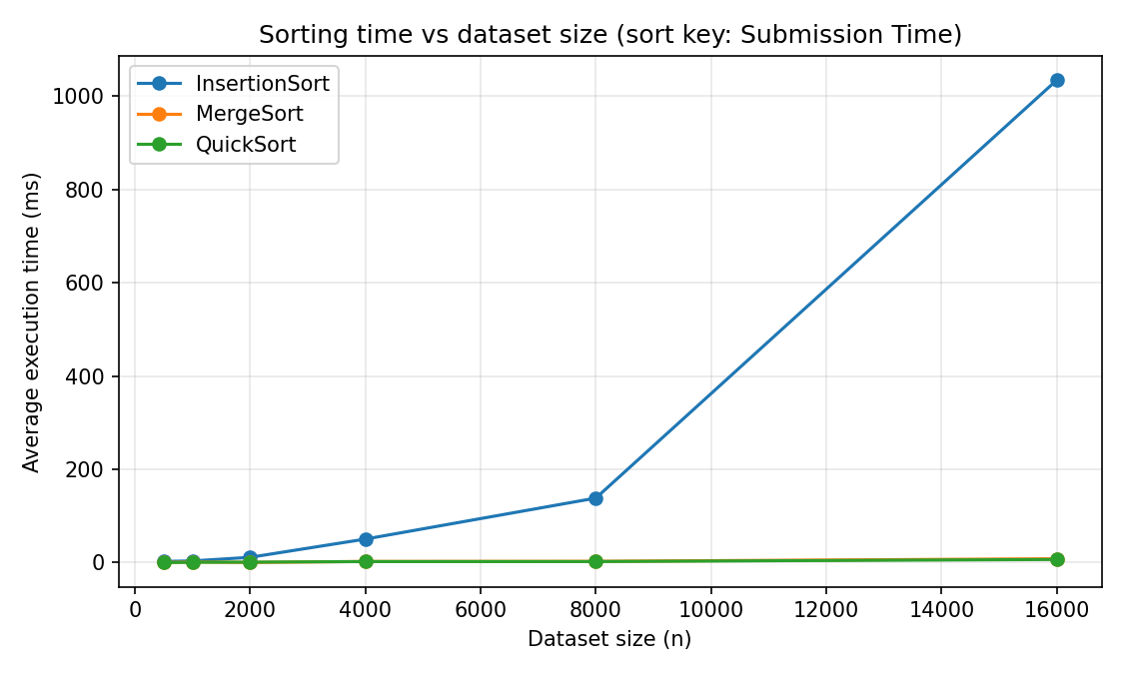
Figure 5. Execution time vs dataset size. Insertion Sort's O(n²) curve rises sharply, while Merge Sort and Quick Sort stay nearly flat by comparison.
At n = 16,000, Insertion Sort took roughly 1.03 seconds versus 6.8–8.4 milliseconds for Merge Sort and Quick Sort — over 120× slower, exactly as predicted by its O(n²) complexity. Merge Sort and Quick Sort track each other closely, with Quick Sort slightly ahead on this uniformly random data, consistent with its lower constant factor from in-place partitioning.

6.2 Duplicate-heavy stress test (sort by Urgency — only 3 distinct values, n = 8,000)
Urgency only takes 3 values (High, Medium, Low), which is a known weak point for Quick Sort's Lomuto partition scheme: partitions become badly unbalanced when many elements are equal.
Insertion Sort (ms) | Merge Sort (ms) | Quick Sort (ms)
31.444 | 7.840 | 108.118
Table 4. Average execution time (ms) sorting by urgency at n = 8,000.
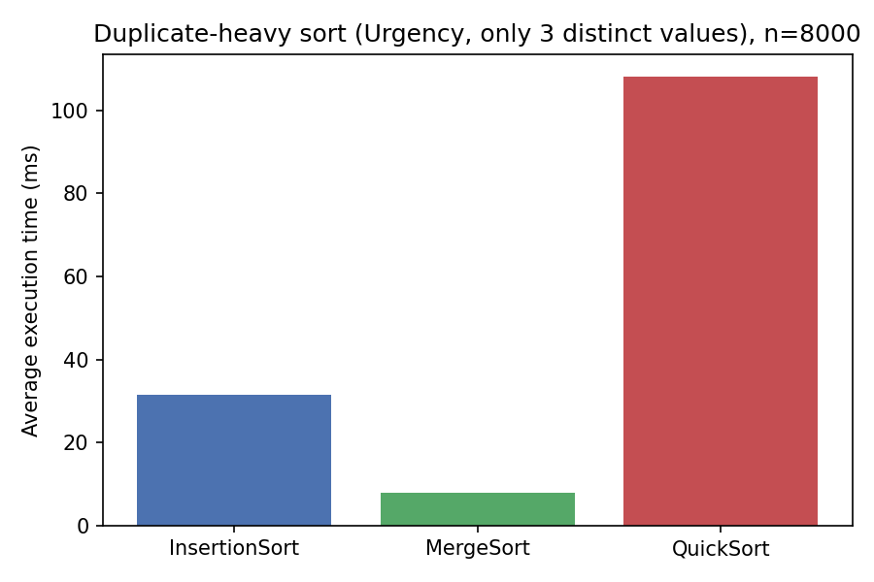
Figure 6. Quick Sort degrades sharply on duplicate-heavy data; Merge Sort is unaffected.
This result is a real, measured demonstration of Quick Sort's worst-case behaviour: it took 108 ms here versus 7.8 ms for Merge Sort — actually slower than Insertion Sort's 31 ms at this size. This is the practical justification for recommending Merge Sort, not Quick Sort, whenever the system sorts by urgency.

6.3 Best-case check: Insertion Sort on nearly-sorted data (n = 2,000)
A dataset was sorted by submission time and then lightly shuffled (about 2% of elements swapped) to simulate a live queue that only drifts slightly out of order between sorts.
Insertion Sort (ms) | Merge Sort (ms) | Quick Sort (ms)
0.365 | 0.335 | 1.072
Table 5. Nearly-sorted data — Insertion Sort is competitive with Merge Sort and beats Quick Sort.
With only light disorder, Insertion Sort's near-O(n) behaviour catches up to Merge Sort and edges out Quick Sort, confirming it is a reasonable choice for small, incremental re-sorts of a live dispatch queue rather than full dataset sorts.

7. Recommendation for the System
- Use Merge Sort as the default for sorting the full request dataset (300 records) by urgency, since it is stable and unaffected by the small number of distinct urgency values.
- Use Quick Sort for sorting by submission time or deadline where values are effectively unique — it is fastest on average and its worst case is avoided by randomized pivot selection.
- Use Insertion Sort only for small, incremental re-sorts of an already-mostly-sorted live queue (e.g. after a single new request arrives), not for full-dataset sorts.

8. Conclusion
All three sorting algorithms were implemented from scratch without relying on banned built-in structures, verified for correctness across all three required sort keys, and benchmarked with real, measured execution times rather than estimated figures. The results confirm the expected theoretical complexity classes and surface a concrete practical case — sorting by urgency — where the naive choice (Quick Sort) is actually the worst option, which will inform how the Sorting Module is wired into the rest of the system during integration.

